Mini Project

Concurrency: Multi-core Programming and Data Processing
Author: Gunakar Challa

Development of the base program
The code is adapted from version 3 of http:/java.rubikscube.info¹ website. The code is first converted from applet to executable Swing program by following the following steps²:
- Change the init method to constructor.
- Adding main method to run the program.
- Modifying the class to extend JFrame.
- Add window handling methods and modifying constructor to use them.
- Adjusting the imports, like removing Applet and adding Swing.

Parallelizing the program
The computation and rendering of the base program is happening on a single Thread called EDT (Event Dispatch Thread).
In the Mandelbrot set, every point in complex plane is independent. Therefore, we can divide the image into many partitions(tasks) and each partition can be computed & rendered independently by a thread. As the program is intended to be invoked with certain number of threads, we have divided each image into (number of threads * 4) partitions. In this way, each thread is assigned 4 tasks.
As some tasks can be computed in less time compared to others, we have further improvised the program by creating a thread pool of fixed number of threads using Executor service and assigning computation of each partition as tasks in the queue to the service. This way all the threads will be busy until the end of the queue. As we are working in a Swing environment, the creation of tasks is done using Swing Workers.
But the change in GUI must be done only in the paint function of the swing program. Hence, we are capturing the pixel colour and position details in the buffered image³.
Lastly when all the swing workers are completed, the paint function is called, and the buffered image is shown in the GUI.

Usage and working of the program
- Compile and run the Main.java file.
- Enter the number of threads to be created. The number of partitions is automatically calculated as number of threads*4.
- The thread pool using provided number of threads is created initially using executor service. The image is split into partitions and these partitions are queued up to thread pool. Each thread in the thread pool calculates a partition, stores the colour value in the buffered image and then continues to take up next partition in the queue.
- When all the partitions are completed, the image is automatically rendered, and time taken is displayed. The thread pool is now idle and is not shutdown.
- The user could press “s” for smoothing the image, “a” for antialiasing the image, “o” to zoom out, “p” for changing colour palette and “esc” to return to initial state. The user could also drag using right click to zoom in and drag using right click while pressing “shift” to move/navigate the image.
- Close the window to safely exit the program and shutdown the thread pool.

Speed Up of the program
The following are observations of the program execution times invoked using 4 threads:

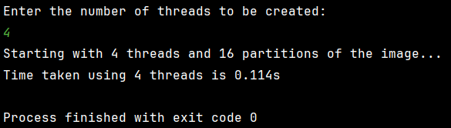
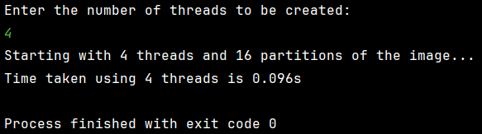
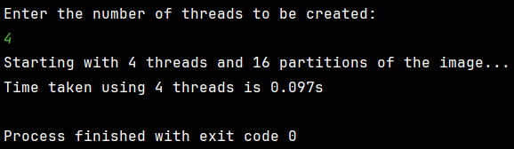
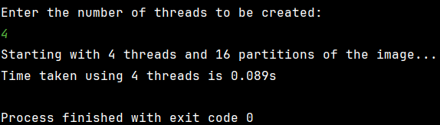
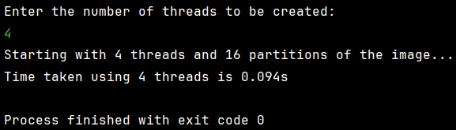

$$Average execution time of the program using 4 threads=sum of execution times of the observations/Total number of observations=\left(0.114+0.096+0.097+0.089+0.094\right)/5=0.49/5=0.098$$

The following are observations of the program execution times invoked using 1 thread:
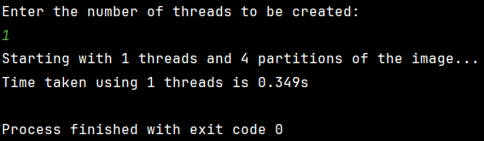
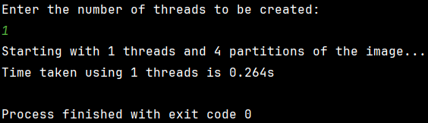
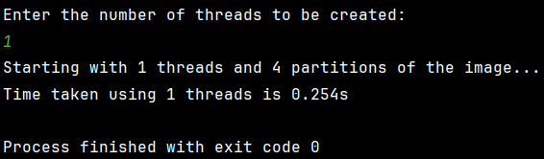
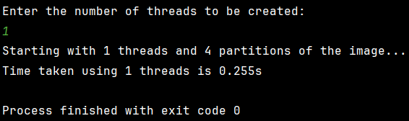
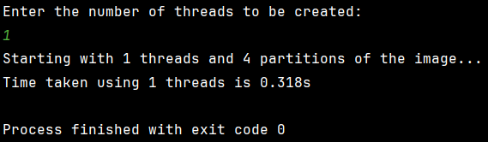

$$Average execution time of the program using 1 thread=sum of execution times of the observations/Total number of observations=\left(0.349+0.264+0.254+0.255+0.318\right)/5=1.44/5=0.288$$

$$Average speed up= Average execution time of the program using 1 thread/Average execution time of the program using 4 threads=0.288/0.098=2.939$$

References
- https://web.archive.org/web/20221218100830/http://java.rubikscube.info/s0urce/Mandel3.java
- AppletToApplication.pdf (tcu.edu)
- ChatGPT

